# **PROJECT DELIVERABLE 3:**

# Submitted BY:

Sabayna Ali (213062)

Immad Amir (210841)

# **SCHEMA:**

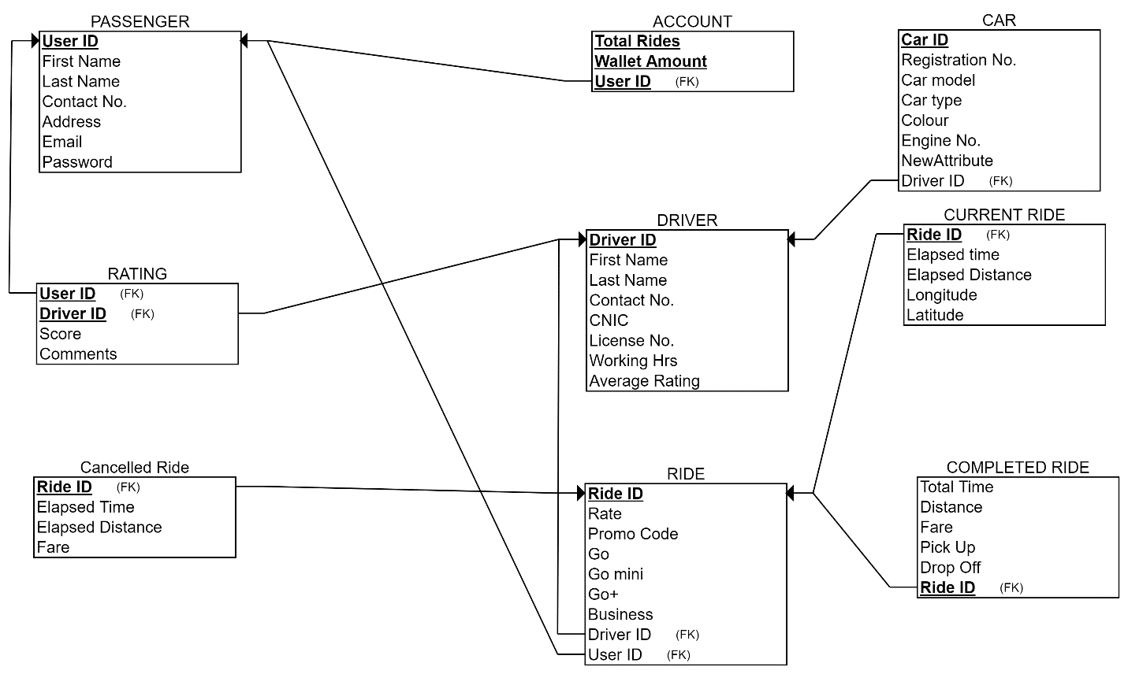

# **Functional Dependencies:**

**PASSENGER:**

User ID 🡪 First Name, Last Name, Contact No., Address, Email, Password

Email 🡪 User ID, First Name, Last Name, Contact No., Address, Password

Contact No. 🡪 User Id, First Name, Last Name, Address, Email, Password

**ACCOUNT:**

User ID 🡪 Total Rides, Wallet Amount

Total Rides 🡪 User ID, Wallet Amount

Wallet Amount 🡪 User ID, Total Rides

**RATING:**

User ID 🡪 Driver ID, Score, Comments

Driver ID 🡪 User ID, Score, Comments

**DRIVER:**

Driver ID 🡪 First Name, Last Name, Contact No., License No., CNIC, Working Hrs, Average rating,

CNIC 🡪 First name, Last Name

License No. 🡪 CNIC, First Name, Last name

**CAR:**

Car ID 🡪 Registration No., Engine No., Car model, Car Type, Color, Driver ID

Registration No. 🡪 Engine No., Car Model, Car type, Color

**RIDE:**

Ride ID 🡪 Rate, Promo Code, Go, Go mini, Go+, Business, User ID, Driver ID

Go 🡪 Rate

Go+ 🡪 Rate

Go mini 🡪 Rate

Business 🡪 Rate

**CURRENT RIDE:**

Ride ID 🡪 Elapses time, Elapsed Distance, Longitude, Latitude

**CANCELLED RIDE:**

Ride ID 🡪 Fare, Elapsed Time, Elapsed Distance

**COMPLETED RIDE:**Ride ID 🡪 Pick Up, Drop Off, Total Time, Distance, Fare